

CAD-CAE
LAB


LIST OF CONTENTS FOR “ICAT FACILITY MANUAL”

INTERNATIONAL CENTRE FOR AUTOMOTIVE TECHNOLOGY

Photograph(s) of Key Facility

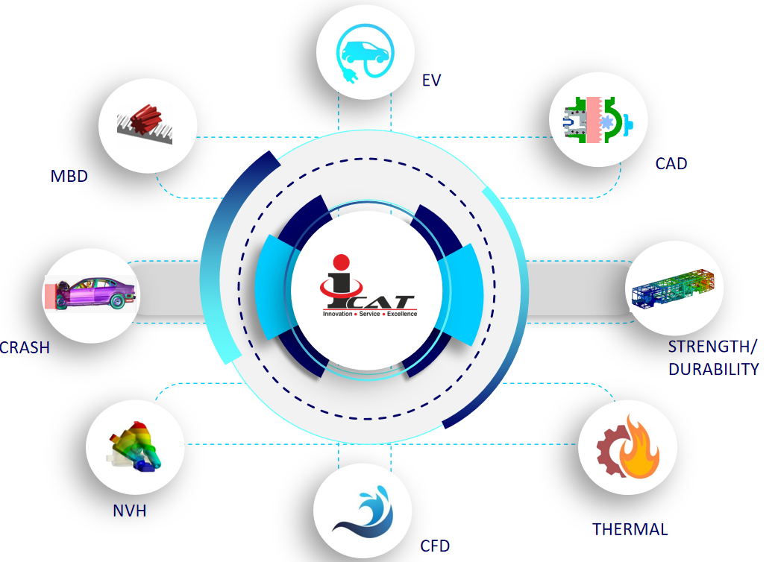
Introduction of Lab or Facility
ICAT is having Computer Aided Design (CAD) and Computer Aided Engineering (CAE) facilities which have come up as the key product development techniques for all manufacturers. Engineering design and analysis plays an important role in the product development. Considering the global competition in the automotive market, the product development needs to be accurate, cost effective and time bounded. We at CAE are offering customized solution from vehicle concept to certification through simulation

Capabilities
- CAD
- Strength and Durability Analysis
- Thermal Analysis
- CFD Analysis
- NVH Analysis
- Crash/Impact Analysis
- Multi-Body dynamics

Specific Capabilities / USPs
- Simulations
  - Natural Frequency of bus structure
  - Rollover analysis of bus structure
  - UBS-II
- Hardware
  - High-performance computing cluster
  - Capability to solve full crash simulations.
  - Altair PBS Job Scheduler for Job Management

Details / Brief Specifications of Test Facilities:

- CAD

  - Solid, Surface Modelling and Assembly
  - Manufacturing Drawing
  - GD&T
  - Design Optimization
- Strength and Durability Analysis
  - Component Structural Analysis
  - Low-cycle & High-Cycle fatigue analysis

  - Transient Shock Analysis
  - Nonlinearity – Contact, Geometry & material
- Thermal Analysis
  - Powertrain cooling
  - Thermal shock for electronics component
  - Exhaust system simulation
  - Battery Thermal Simulation

  - Thermal Stress fatigue analysis
- CFD Analysis
  - Port flow & Exhaust system analysis
  - FSI-Fluid Structure Interaction
  - Battery cooling
  - Conjugate heat transfer analysis
- NVH Analysis
  - Components Modal Analysis.

  - Harmonic Analysis
  - Random Vibration and Vibration Fatigue analysis
- Crash/Impact Analysis
  - Correlation to physical prototypes
  - Energy Management Strategy
  - Evaluation of FOPS & ROPS for Construction Equipment & Mining Vehicles
  - Design of Vehicle Barriers (Bollard / Blocker)
- Multi-Body dynamics

  - Mechanism Simulation
  - Calculation of forces through MBD
  - Vehicle dynamics

Key Projects Executed:

Design of Vehicle Bollard Barrier and Evaluation as per
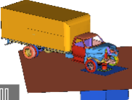
ASTM F2656 / PAS 68 / IWA 14-1

The Bus is tested as bump and torsional analysis as per the
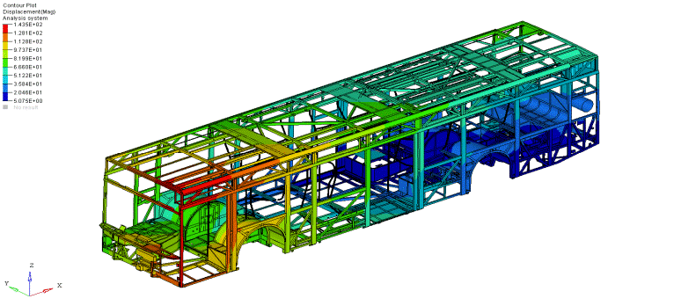
standard of mentioned in UBS-II

Design and development of the Manual Rack and
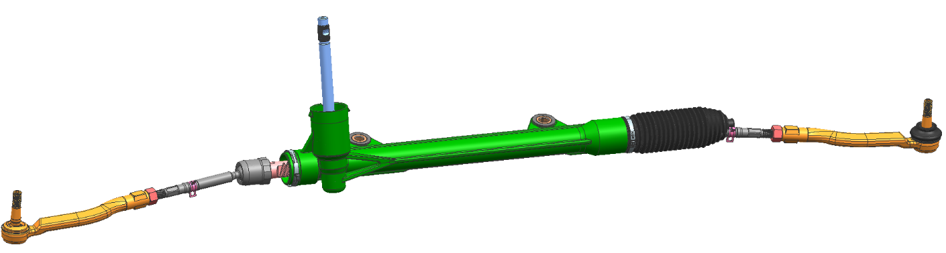
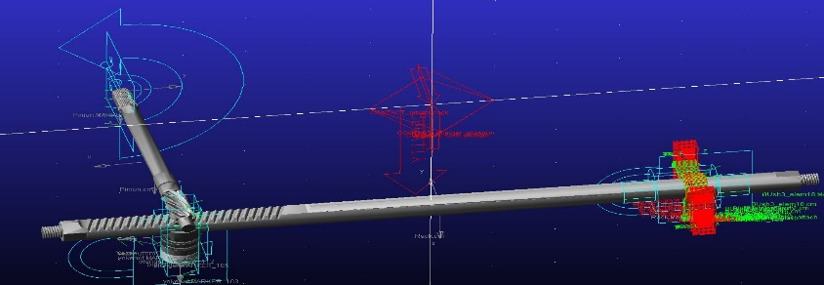
Pinion Cross-Helical Steering Gear

Standards / Regulations (National & International):

Segment | Test | Standard
TRAILER-PV | Physical Verification - Dimensional Checks | AIS-113
TRAILER-PV | Installation Requirement of Lighting and Signalling Device | AIS-008 (Rev.1)
TRAILER-PV | Interchangeability Of Mechanical Coupling of Semi-Trailers | IS 8007:2004
TRAILER-PV | Spray Suppression System Test (Installation Level) | AIS-013 (Rev.1)
TRAILER-PV | Physical Verification - External Projection | IS 13942:1994
TRAILER-PV | Vehicle Maneuverability Requirement Test & Vehicle Weighment | IS 12222:2011
TRAILER-PV | Strength and installation test of SUPD | IS 14682:2004
TRAILER-PV | Strength and installation test of RUPD | IS 14812:2005
2-W | Protective Devices for Two Wheeled Motor Vehicles (Saree Guard) | AIS-166
CEV | Evaluation of Min. Operator Space Envelop | ISO 3411:2007
CEV | Evaluation of ZOR, ZOC | ISO 6682:2008
BUS | Bus CG measurement | IS 11849:2024
BUS | Modal analysis of bus structure | AIS-153
BUS | Rollover analysis of bus structure | AIS-031
BUS | Rollover analysis of sleeper bus structure | AIS-119 (Rev.1)
BUS | Bus stability | AIS-052 (Rev.1)
BUS | Strength and installation test of SUPD | IS 14682:2004
BUS | Physical verification of Bus | AIS-052 (Rev.1) & AIS-153
BUS | Lighting installation and signalling device | AIS-008 (Rev.1)
BUS | External Projection | IS 13942:1994
BUS | Handholds | AIS-046
TRUCK | Truck cabin Front, roof & rear strength test | AIS-029
TRUCK | Load body strength test | AIS-093 (Rev.1)
TRUCK | FUPD Physical verification and simulation | AIS-069
TRUCK | Physical verification as per AIS 093 | AIS 093 (Rev.1)
TRUCK | Lighting installation and signalling device | AIS 008 (Rev.1)
TRUCK | Spray Suppression Installation | AIS-013 (Rev.1)
TRUCK | External Projection | IS 13942:1994
TRUCK | Handholds | AIS-046

Correlation & Benchmarking:

Objective
Physical CAE
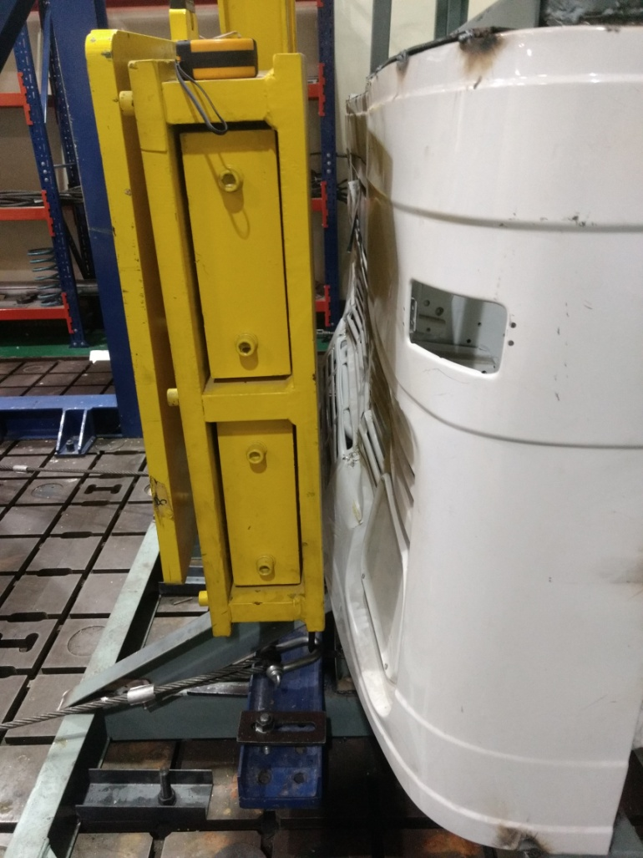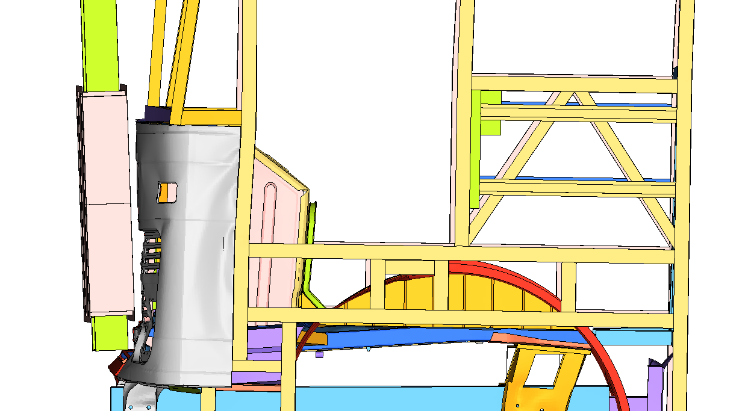
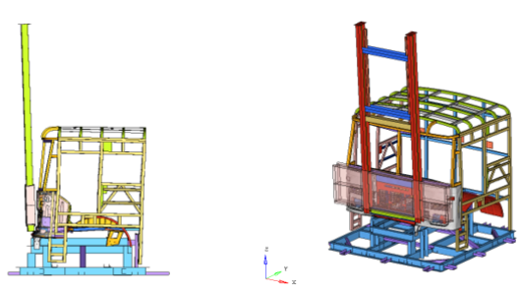

To perform the CAE of Frontal Impact of the Truck CAB as per AIS 029 and validate from the physical model.

Scope
- The frontal impact of the truck cabin is performed as per AIS 029 impact condition
- Energy absorption evaluation simulation done as per ISO IWA 14-1standard using RADIOSS.
- The physical test is performed in the ICAT facility
- Result is compared of CAE and Physical and study the correlation

Objective
Physical


CAE
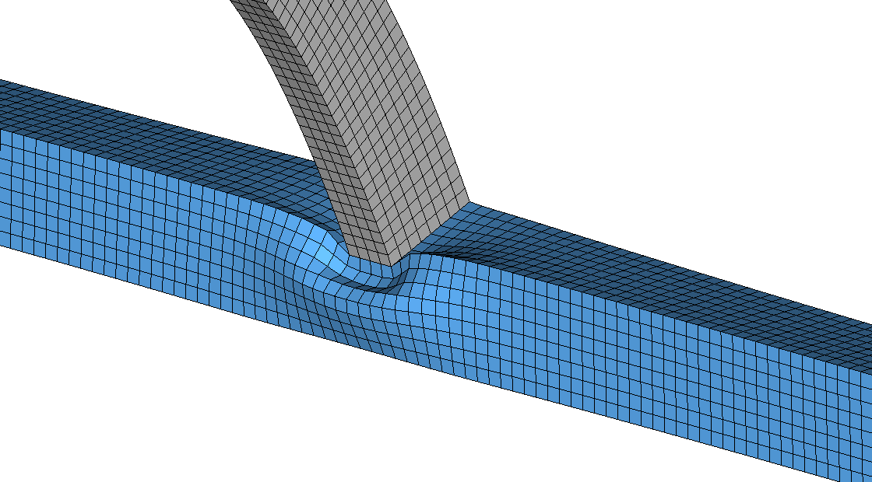
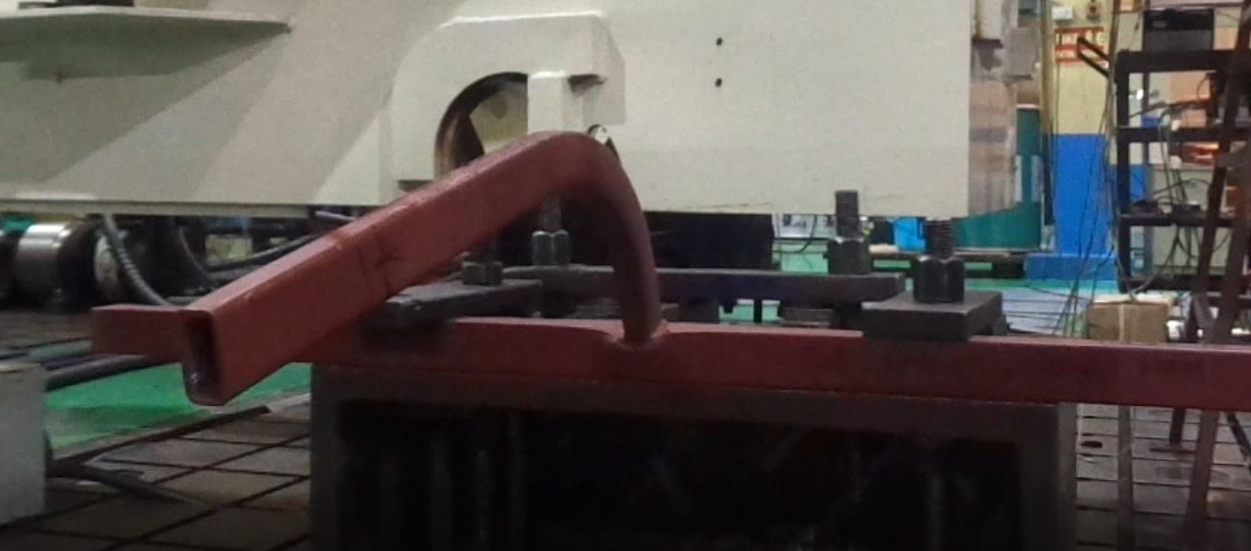
To conduct computer-aided engineering (CAE)–based structural analysis of the bus roof joint and perform physical correlation to validate stress, deformation, and structural behaviour under specified loading conditions.
Scope
- Develop CAD and FE models of the bus roof joint.
- Perform CAE-based structural analysis under relevant load conditions.
- Evaluate stress, strain, and deformation behavior.
- Identify critical regions in the joint.
- Correlate CAE results with physical test data for validation.
- Result is compared of CAE and Physical and study the correlation

CAD-CAE LAB
E-mail: cae@icat.in Phone: +91-7042130088 Website: www.icat.in
International Centre for Automotive Technology
Centre- 1, Plot No. 26, Sector- 3, IMT Manesar, Gurugram- 122050, Haryana (INDIA)

